2.

先利用栈把1 3 5…99存进去

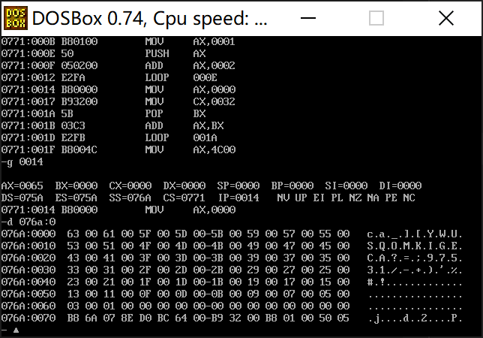

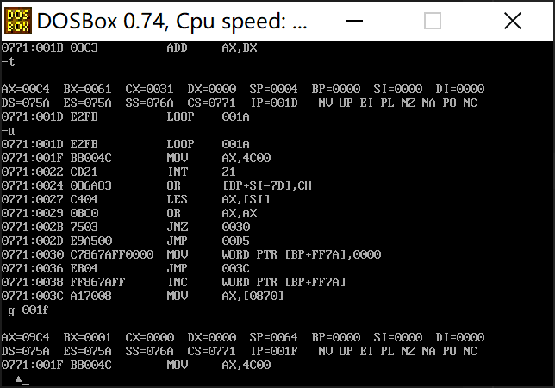

Cx为0时退出循环

最后结果在ax中

assume cs:code ss:stack

stack segment

dw 50 dup(0)

stack ends

code segment

start:mov ax,stack

mov ss,ax

mov sp,100

mov cx,50

mov ax,1

s: push ax

add ax,2

loop s

mov ax,0

mov cx,50

s0: pop bx

add ax,bx

loop s0

mov ax,4c00H

int 21h

code ends

end start

3.

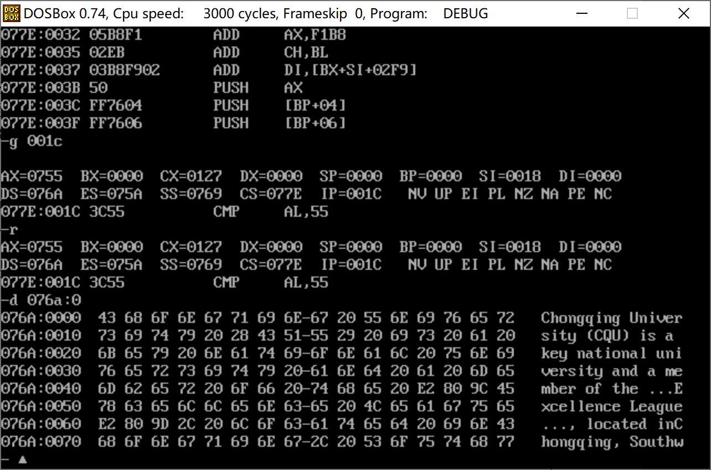

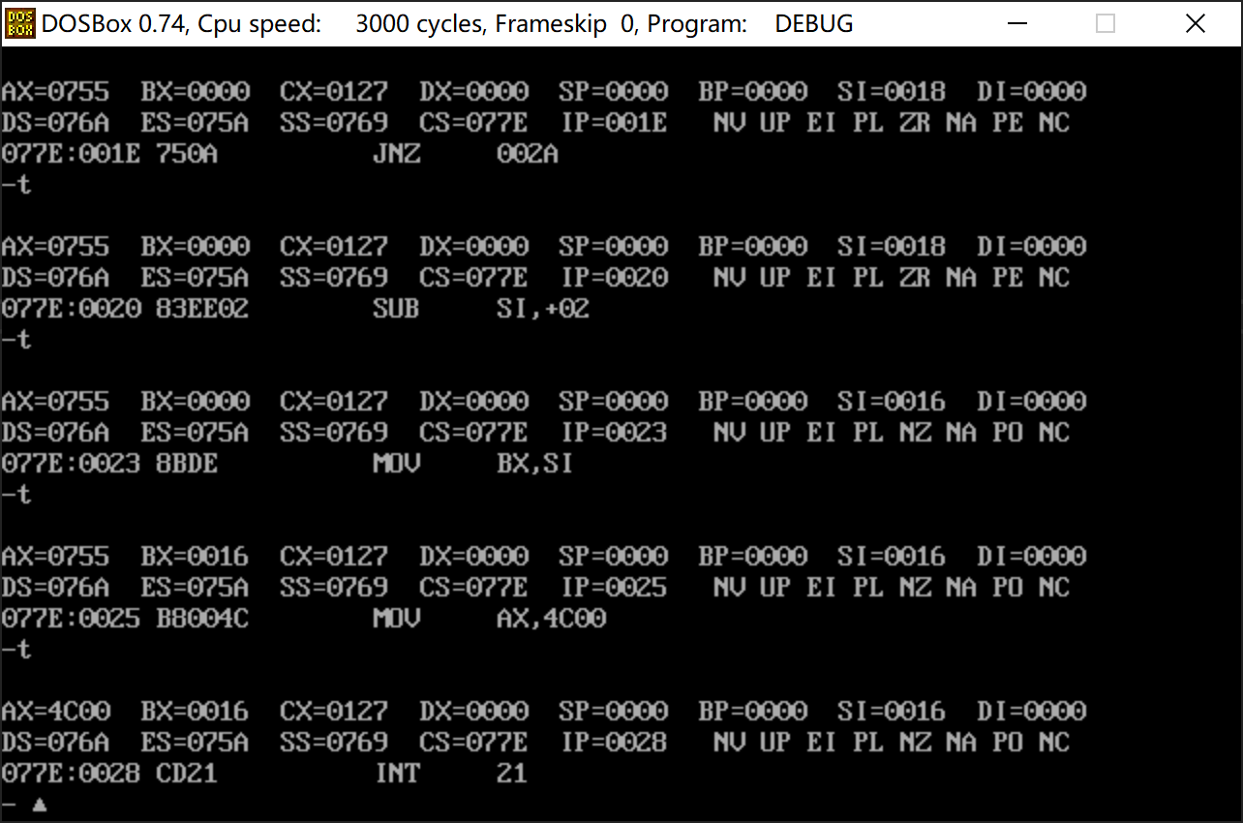

最后结果：bx 16H

代码：

assume cs:code, ds:data

data segment

string db"Chongqing University (CQU) is "

db "a key national university "

db "and a member of the “Excellence League”, located in"

db "Chongqing, Southwest China. It is also one of"

db "the '211 Project' and '985 Projec' universities with full "

db "support in construction and development from the"

db "central government and Chongqing Municipal Government.","$"

data ends

code segment

start:

mov ax,data

mov ds,ax

lea si,string

mov cx,316

s: mov al,[si]

cmp al,"C"

jnz next

inc si

mov al,[si]

cmp al,"Q"

jnz next

inc si

mov al,[si]

cmp al,"U"

jnz next

sub si,2

mov bx,si

mov ax,4c00H

int 21h

next:

inc si

loop s

mov ax,4c00H

int 21h

code ends

end start